**Summarization of Percentile:**

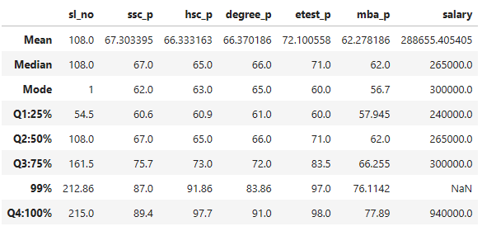

1. **ssc_p:**

* Q1 (25%): 60.6
* Q2 (50%): 67.0
* Q3 (75%): 75.7
* 99%: 87.0
* Q4 (100%): 89.4

The improvement from Q1 (25%, which is 60.6) to Q2 (50%, which is 67) is 6.4. The progression continues, with an improvement of 8.7 from Q2 to Q3 (75%, which is 75.7). In the 99th percentile (99%, which is 87), there's an improvement of 11.3. Finally, from Q3 to Q4 (100%, which is 89.4), there's an improvement of 2.4.

1. **hsc_p:**

* Q1 (25%): 60.9
* Q2 (50%): 65.0
* Q3 (75%): 73.0
* 99%: 91.86
* Q4 (100%): 97.7

The hsc_p value is from Q1 (25%, which is 60.9) to Q2 (50%, which is 65.0), with an improvement of 4.1. There's a further improvement of 8.0 from Q2 to Q3 (75%, which is 73.0). In the 99th percentile (99%, which is 91.86), there's a substantial improvement of 18.86. Finally, from Q3 to Q4 (100%, which is 97.7), there's a modest improvement of 4.7.

1. **degree_p:**

* Q1 (25%): 61.0
* Q2 (50%): 66.0
* Q3 (75%): 72.0
* 99%: 83.86
* Q4 (100%): 91.0

The degree_p value is from Q1 (25%, which is 61.0) to Q2 (50%, which is 66.0), with an improvement of 5.0. There's a slight decrease of 6.0 from Q2 to Q3 (75%, which is 72.0). In the 99th percentile (99%, which is 83.86), there's a notable increase of 17.86. Finally, from Q3 to Q4 (100%, which is 91.0), there's a substantial improvement of 19.0.

1. **e test_p:**
   * Q1 (25%): 60.0
   * Q2 (50%): 71.0
   * Q3 (75%): 83.5
   * 99%: 97.0
   * Q4 (100%): 98.0

The e test_p value is from Q1 (25%, which is 60.0) to Q2 (50%, which is 71.0), with an improvement of 11.0. This trend continues, with a substantial increase of 12.5 from Q2 to Q3 (75%, which is 83.5). In the 99th percentile (99%, which is 97.0), there's a noteworthy improvement of 15.0. Finally, from Q3 to Q4 (100%, which is 98.0), there's a modest improvement of 14.5.

1. **mba_p:**

* Q1 (25%): 57.945
* Q2 (50%): 62.0
* Q3 (75%): 66.255
* 99%: 76.1142
* Q4 (100%): 77.89

The mba_p value is from Q1 (25%, which is 57.945) to Q2 (50%, which is 62.0), with an improvement of 4.055. This trend continues, with a further increase of 4.255 from Q2 to Q3 (75%, which is 66.255). In the 99th percentile (99%, which is 76.1142), there's a notable improvement of 9.8592. Finally, from Q3 to Q4 (100%, which is 77.89), there's a modest improvement of 11.6342.

1. **Salary:**

* Q1 (25%): 57,945.0
* Q2 (50%): 265,000.0
* Q3 (75%): 300,000.0
* 99%: 76,114.2 (with NaN)
* Q4 (100%): 940,000.0

The salary value is from Q1 (25%, which is 57,945.0) to Q2 (50%, which is 265,000.0), with a substantial improvement of 207,055.0. This trend continues, with a further increase of 35,000.0 from Q2 to Q3 (75%, which is 300,000.0). However, in the 99th percentile, there's no specific value provided (NaN). Finally, from Q3 to Q4 (100%, which is 940,000.0), there's a notable improvement of 640,000.0.